Regulations:
A18

H.T No

Sreenidhi Institute of Science and Technology
(An Autonomous Institution)
Code No: 7A201 Date: 18-June-2019 (FN)

B.Tech I-Year II-Semester External Examination, June-2019 (Regular)
ELECTRICAL CIRCUITS AND NETWORKS-I (EEE)

Time: 3 Hours Max.Marks:70

Note: a) No additional answer sheets will be provided.
b) All sub-parts of a question must be answered at one place only, otherwise it will not be valued.
c) Missing data can be assumed suitably.

Part - A Max.Marks:20

Answer all QUESTIONS.

1. | If the current in the inductor of 4H varies at a rate of 3 Amp/Second. Find the voltage across the inductor and the energy stored in the inductor after 3 seconds. | [2M]
2. | What is duality? Give some dual elements. | [2M]
3. | Briefly explain about Dot convention. | [2M]
4. | A 50µF capacitor is connected across a 230V, 50Hz supply, calculate the maximum and R.M.S values of the current. | [2M]
5. | Draw the locus diagram of R-L Series circuit. | [2M]
6. | State Thevenin’s theorem. | [2M]
7. | Obtain the star equivalent circuit for the delta connected resistors of value 12Ω as shown below  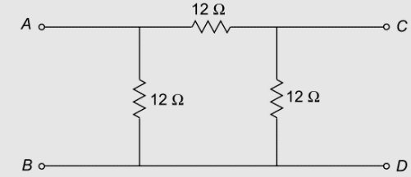 | [2M]
8. | The two similar coils have a coupling coefficient of 0.25. when they are connected in series cumulatively, the total inductance is 80mH. Calculate the self-inductance of each coil. | [2M]
9. | State Reciprocity theorem with an example. | [2M]
10. | A sinusoidal voltage is applied to a series RL circuit. The current in the circuit is given by . Determine i) apparent power, ii) power factor iii) average power. | [2M]
Part – B Max.Marks:50
ANSWER ANY FIVE QUESTIONS. EACH QUESTION CARRIES 10 MARKS.

11. | a) | Determine the current in the 5Ω resistor in the circuit shown below using nodal analysis.  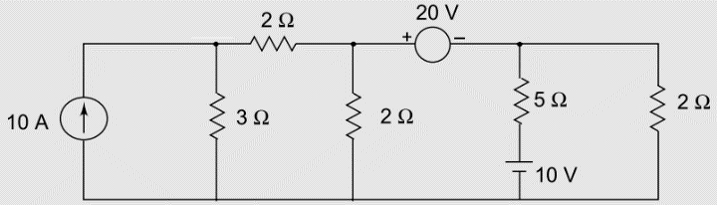 | [5M]
 | b) | Find the resistance between A and B terminals of the circuit shown below.  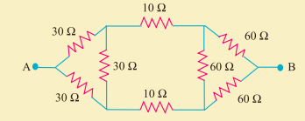 | [5M]
12. | a) | For the network shown below, draw the oriented graph, select a suitable tree and obtain the fundamental cut-set matrix.  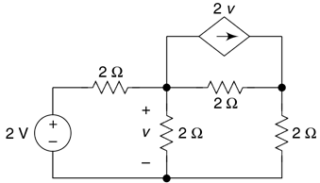 | [5M]
 | b) | Determine the currents in all branches of the network shown below, using node analysis method, use graph theory method,  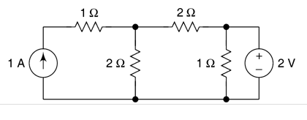 | [5M]
13. | a) | Explain about faraday’s law of electromagnetic induction and write its application. | [5M]
 | b) | Find the equivalent inductance across the terminals ab for the coupled circuit shown below. All coils are coupled and M=0.5H.  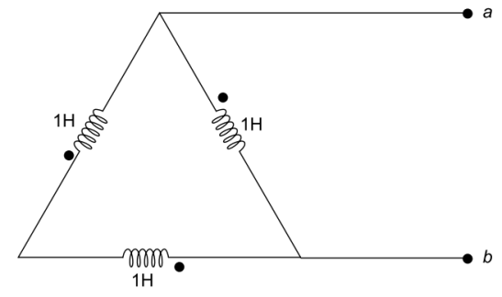 | [5M]
14. | a) | Find Average, R.M.S, form factor, peak factor for the waveform shown below.  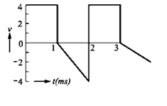 | [5M]
 | b) | What is RMS value and average value. Derive an expression for anaverage value and RMS value for a sinusoidal voltage in terms of its maximum value. | [5M]
15. | a) | For the parallel circuit shown below figure, draw the locus diagram of The range of values for R₁ between 10Ω and 100Ω. Assume and . The supply voltage is 220V and the frequency is 50Hz, both held constant.  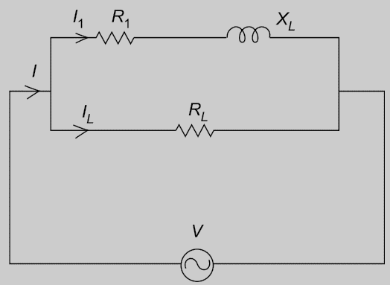 | [5M]
 | b) | Resistor R=20Ω, inductor of value 0.2H and capacitor value of 50µF are connected in series connected to a 100 RMS voltage source. Determine the frequency at which the voltage across the inductor at resonance and the Q factor of the circuit. | [5M]
16. | a) | State Millman’s theorem and find the node voltage V and current in the j4 impedance shown in the circuit below.  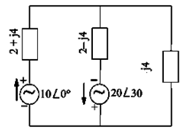 | [5M]
 | b) | State superposition theorem and find the power dissipated by the 5Ω resistor in the circuit shown below.  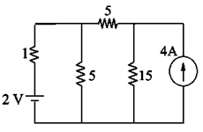 | [5M]
17. | a) | Find the resistance between A and B terminals in the figure shown below.  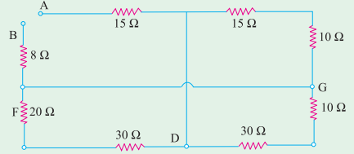 | [4M]
 | b) | Obtain the expression for coefficient of coupling in magnetic circuits. | [3M]
 | c) | Define tree, co-tree and explain about the properties of a tree | [3M]
18. | a) | Explain about Active power, Apparent Power and Reactive power. | [4M]
 | b) | Explain about resonance in Parallel RLC circuit. | [3M]
 | c) | Briefly explain about Tellegen’s theorem. | [3M]

-- 00 -- 00 –

